

DAA WEEK – 7 SKILL – 7



# [Breaking the Records](https://www.hackerrank.com/contests/daa-skill-07-divide-and-conquer-scenario-part-1/challenges/breaking-best-and-worst-records/problem)

#include <stdio.h>

void f(int a[], int b, int *c, int *d) {

int e = a[0], f = a[0];

*c = 0;

*d = 0;

for (int g = 1; g < b; g++) {

if (a[g] > e) {

e = a[g];

(*c)++;

}

if (a[g] < f) {

f = a[g];

(*d)++;

}

}

}

int main() {

int h;

scanf("%d", &h);

int i[h];

for (int j = 0; j < h; j++) {

scanf("%d", &i[j]);

}

int c, d;

f(i, h, &c, &d);

printf("%d %d\n", c, d);

return 0;

}

**Breaking the Records Test Cases**

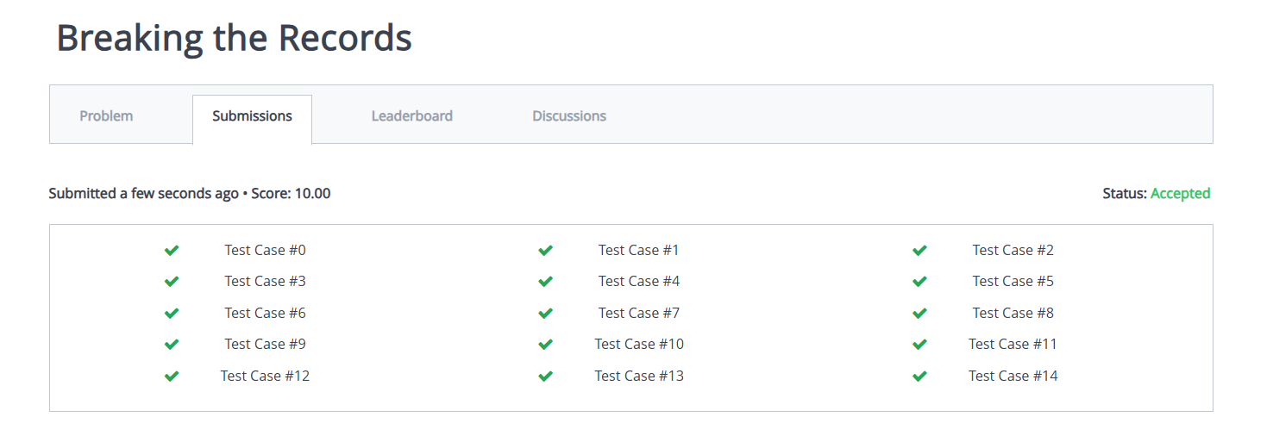

# [Subarray Division](https://www.hackerrank.com/contests/daa-skill-07-divide-and-conquer-scenario-part-1/challenges/the-birthday-bar)

#include <stdio.h>

int birthday(int a[], int b, int c, int d) {

int e = 0;

if (b == 1) return 1;

for (int f = 0; f < b; f++) {

int g = 0;

for (int h = f; h < f + d; h++) {

if (h < b) g += a[h];

}

if (g == c) e++;

}

return e;

}

int main() {

int i;

scanf("%d", &i);

int j[i];

for (int k = 0; k < i; k++) scanf("%d", &j[k]);

int l, m;

scanf("%d %d", &l, &m);

printf("%d\n", birthday(j, i, l, m));

return 0;

}

**Subarray Division Test Cases**

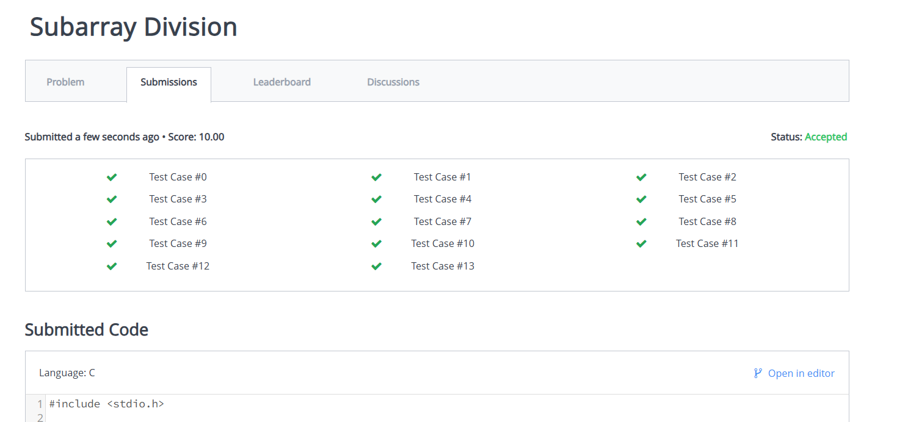

# [Divisible Sum Pairs](https://www.hackerrank.com/contests/daa-skill-07-divide-and-conquer-scenario-part-1/challenges/divisible-sum-pairs)

#include <stdio.h>

int divisibleSumPairs(int n, int k, int ar[]) {

int count = 0;

for (int i = 0; i < n; i++) {

for (int j = i + 1; j < n; j++) {

if ((ar[i] + ar[j]) % k == 0) {

count++;

}

}

}

return count;

}

int main() {

int n, k;

scanf("%d %d", &n, &k);

int ar[n];

for (int i = 0; i < n; i++) {

scanf("%d", &ar[i]);

}

printf("%d\n", divisibleSumPairs(n, k, ar));

return 0;

}

**Divisible Sum Pairs Test Cases**

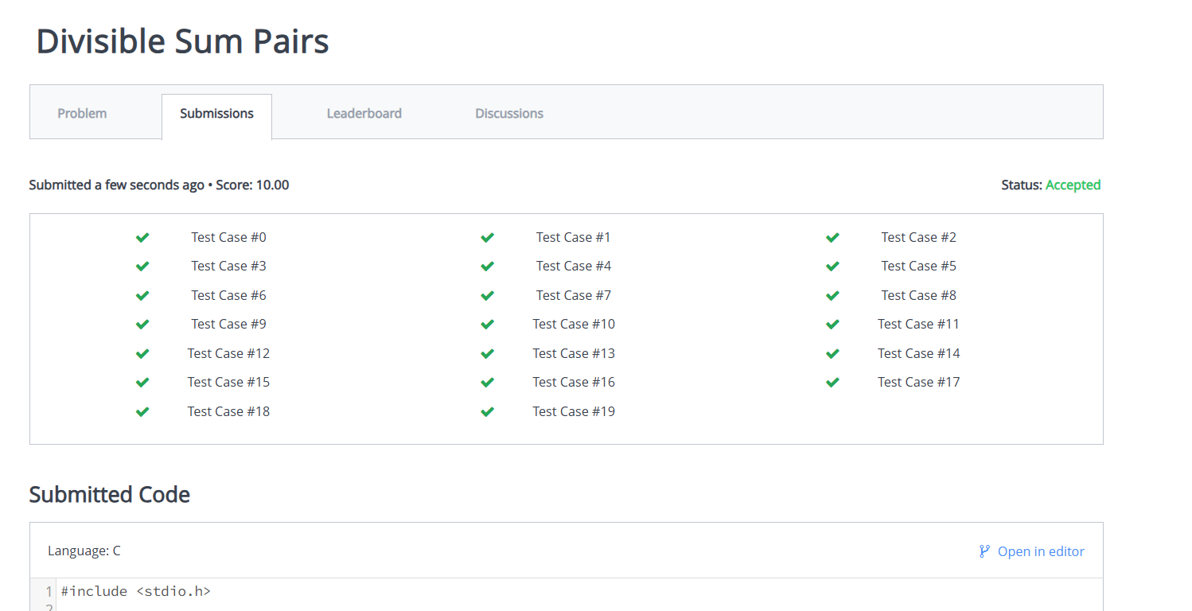

# [Migratory Birds](https://www.hackerrank.com/contests/daa-skill-07-divide-and-conquer-scenario-part-1/challenges/migratory-birds)

#include <stdio.h>

int migratoryBirds(int arr[], int n) {

int buckets[6] = {0}, i, max_count = 0, result = 1;

for (i = 0; i < n; i++)

buckets[arr[i]]++;

for (i = 1; i < 6; i++) {

if (buckets[i] > max_count) {

max_count = buckets[i];

result = i;

}

}

return result;

}

int main() {

int n, i;

scanf("%d", &n);

int arr[n];

for (i = 0; i < n; i++)

scanf("%d", &arr[i]);

printf("%d\n", migratoryBirds(arr, n));

return 0;

}

**Migratory Birds Test Cases**

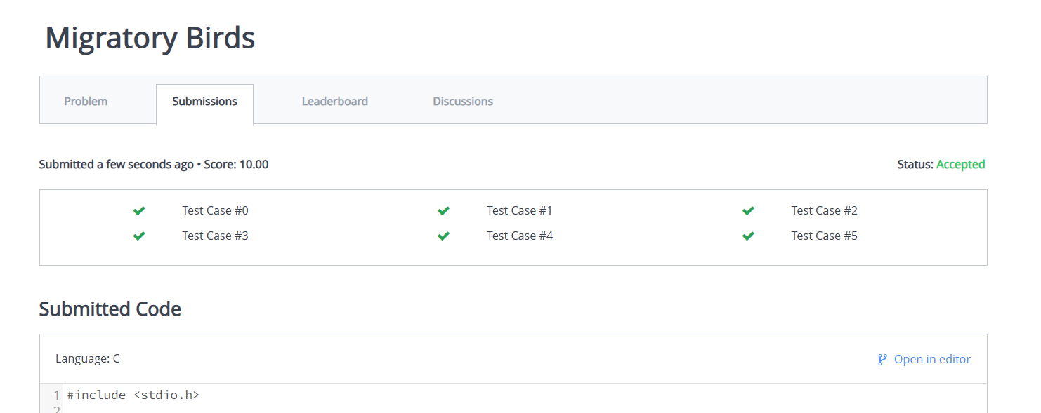

# [Sales by Match](https://www.hackerrank.com/contests/daa-skill-07-divide-and-conquer-scenario-part-1/challenges/sock-merchant)

#include <stdio.h>

int sockMerchant(int n, int ar[]) {

int count = 0, freq[101] = {0};

for (int i = 0; i < n; i++)

freq[ar[i]]++;

for (int i = 0; i < 101; i++)

count += freq[i] / 2;

return count;

}

int main() {

int n;

scanf("%d", &n);

int ar[n];

for (int i = 0; i < n; i++)

scanf("%d", &ar[i]);

printf("%d\n", sockMerchant(n, ar));

return 0;

}

**Sales by Match Test Cases**

**SKILL WEEK – 7**

[**https://www.hackerrank.com/contests/daa-skill-07-divide-and-conquer-scenario-part-1/challenges/sock-merchant**](https://www.hackerrank.com/contests/daa-skill-07-divide-and-conquer-scenario-part-1/challenges/sock-merchant)